- Draw a labeled diagram of an ATX motherboard and mark at least 8 different slots and ports

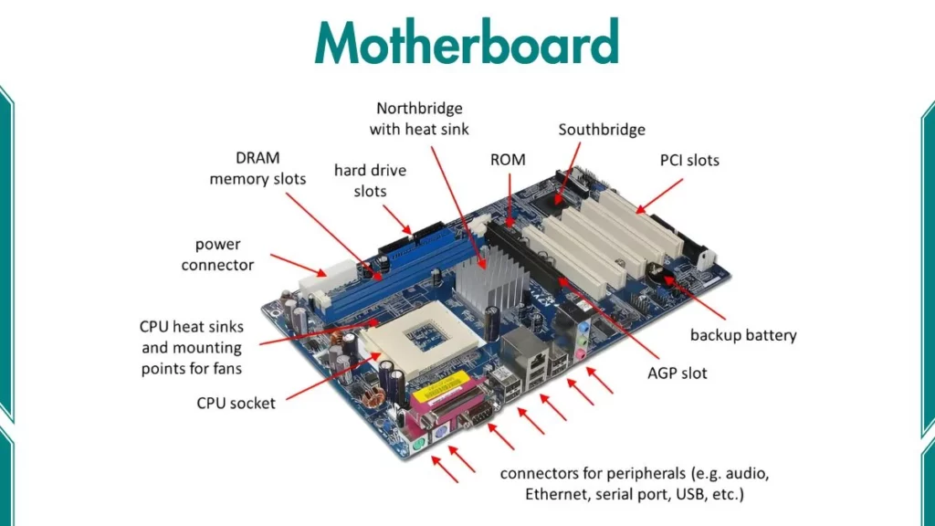

- Research and list 3 popular CPU socket types (for example: LGA1151, AM4, LGA1200) and name one compatible CPU model for each.

LGA 1151 (Initial Version)
- Supported CPUs: 6th gen and 7th gen
- Compatible Motherboards: 100-series and 200-series chipsets
- Notable Processors: Intel Core i7-7700K, Core i5-6600K.

2. AMD Socket AM4
- Supported CPUs: AMD Ryzen 1000 through 5000 series processors
- Memory Support: DDR4
- Pin Type: PGA

3. LGA 1200
- Supported CPUs: 10th and 11th
- Compatible Motherboards: Intel's 400-series and 500-series
- Memory Support: DDR4

3. Explain in your own words the primary functions of the CPU and the chipset on a motherboard, and describe how they work together when you open a music app like Spotify.

How They Work Together (Opening Spotify)
When you double-click on a music app like Spotify, the two components coordinate to get the music playing:
- The Request: When you click the app, your click is sent through the USB port or touchpad. The chipset acts as a messenger, passing this "open" signal to the CPU. [1, 2]
- Loading the App: The CPU reads instructions on how to open Spotify, retrieves the app's files from your storage (like an SSD), and loads them into your short-term memory (RAM). [1, 2, 3, 4, 5]
- Playing the Music: The CPU calculates the digital music data (decoding the audio files) and sends those processed signals back to the chipset. [1, 2]
- Output: The chipset routes this stream of audio data to your computer's audio chip or connected speakers. [1, 2]

4. Find a clear photo of a real motherboard (from the internet or your own device), and identify at least 5 different ports or slots by circling them and labeling each one.

